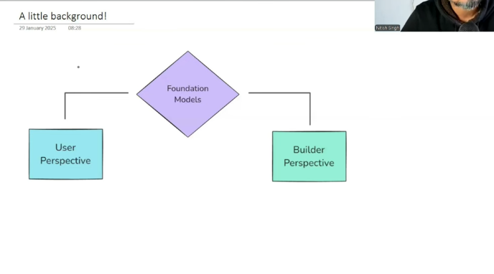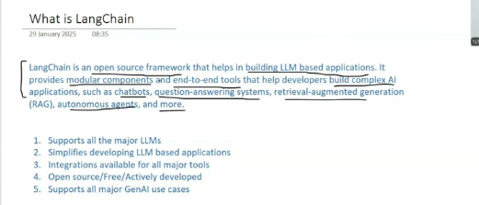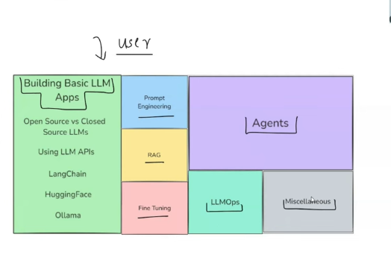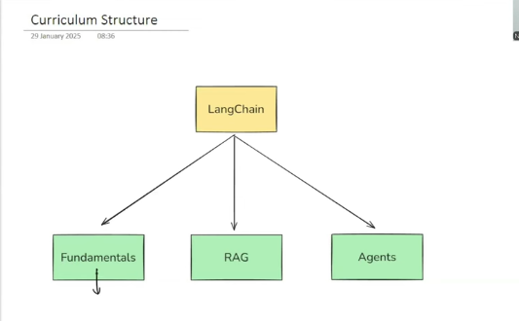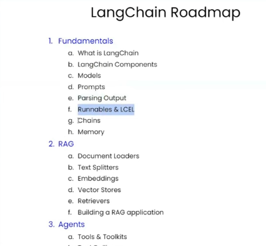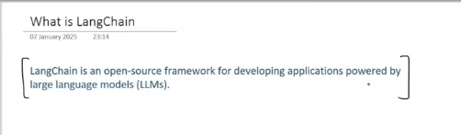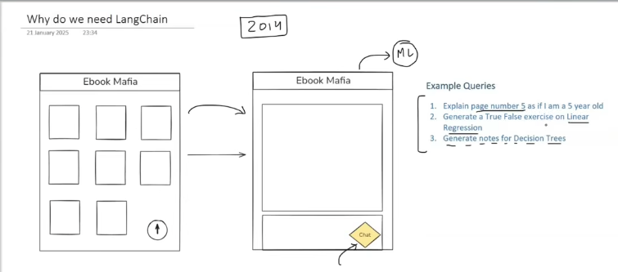

Consider it as the application which uses the chatbot wth pdfs.

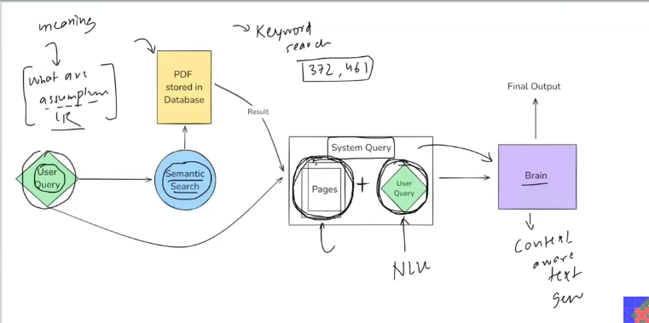

Keyword search:

Semantic search:

Brain   
1. Understand the context the user is asking.

2. Based on the question asked, go to the document and based on that answer the question.

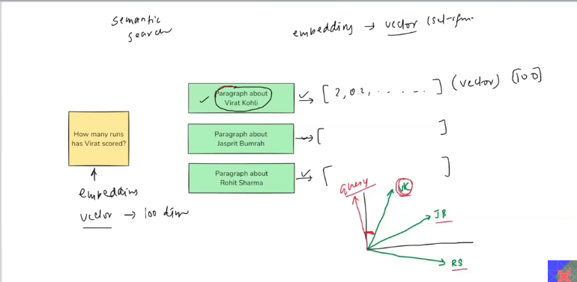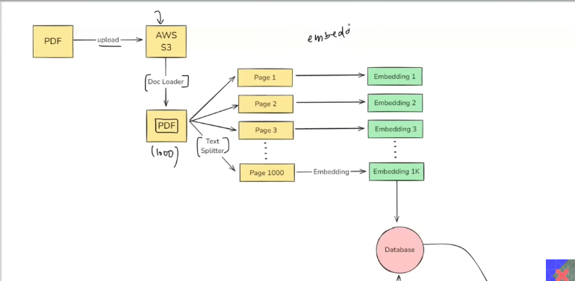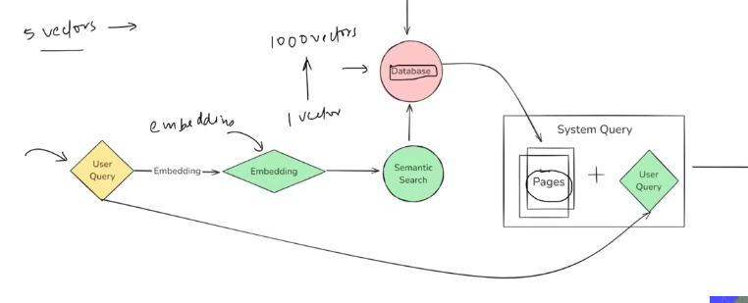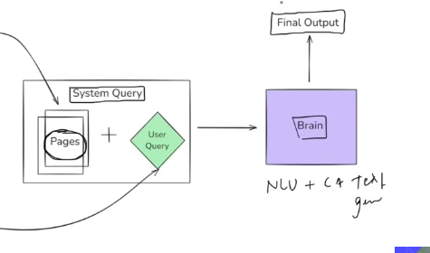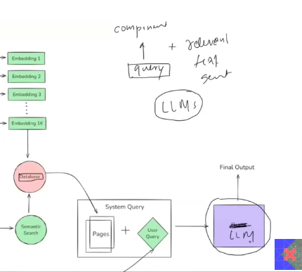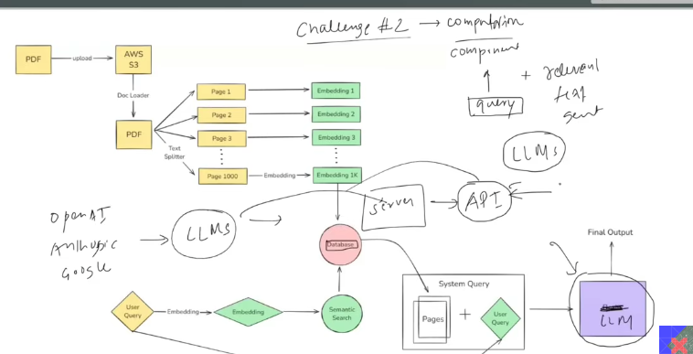

What is the number of moving component:

1. AWS S3
2. TEXT SPLITTER
3. EMBEDDING - MODEL
4. DATABASE – TO STORE THE EMBEDDING.
5. LLM

The boiler plate codes are removed using langchain library.

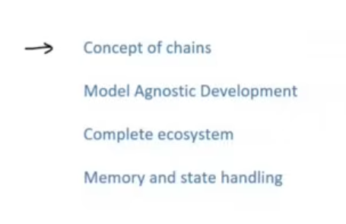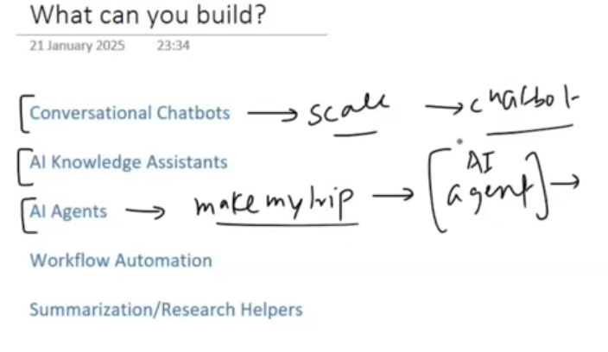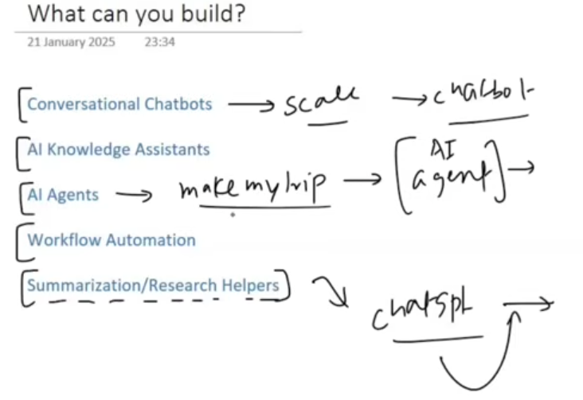

Chain: Output from the one can be given as input to the other function.

**Components in Langchain** (6)

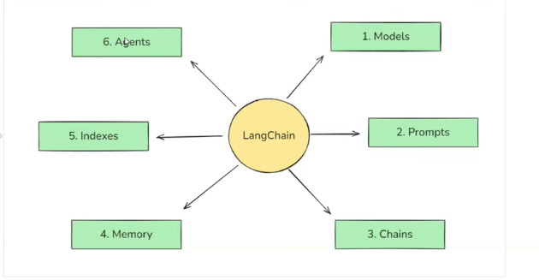

Thinks about the AGENTIC RAG, tell what are all there in that, so it wil be esy tp say everything about it.

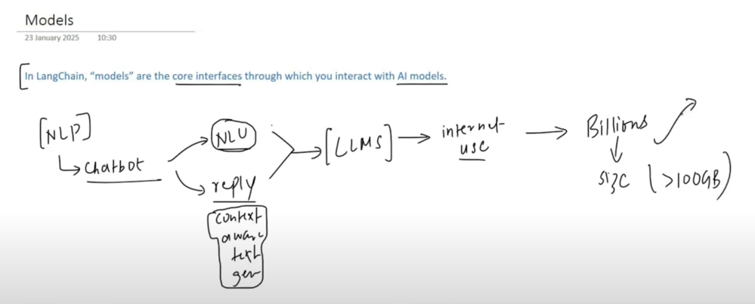

Llms are too huge to fit into the laptop , cannot make the moeny to deploy in the cloud, hnec we are going to use the apis to llms. Based on the api call usage , you need to make the payments.

No general output.

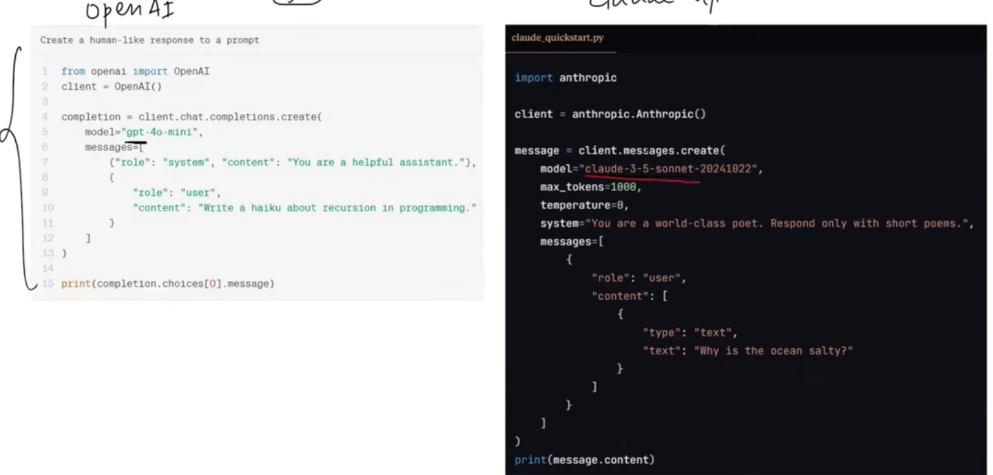

But need the general way to communicate. Hence we use the langchain.

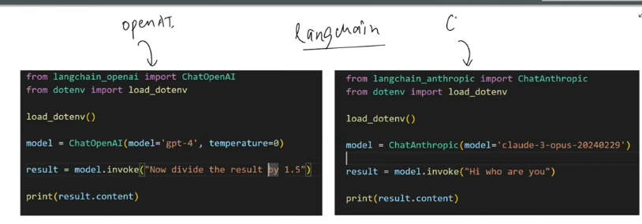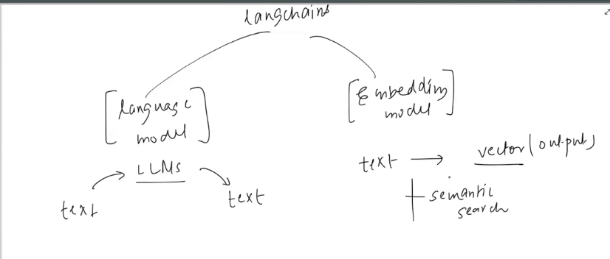

**Langchain – documentation - chat models - llms**

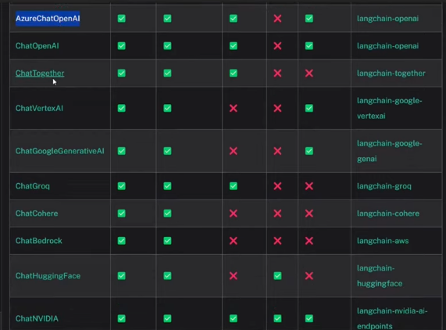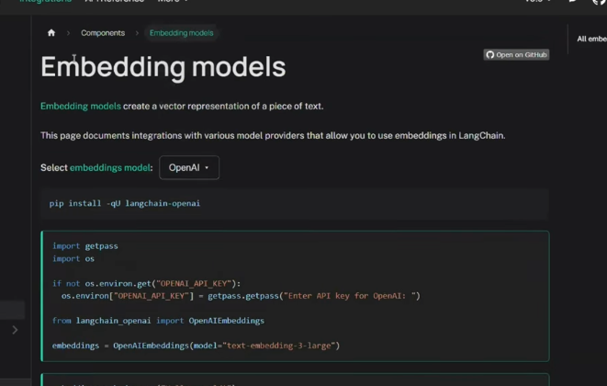

**PROMPTS**

INPUT TO THE LLMS

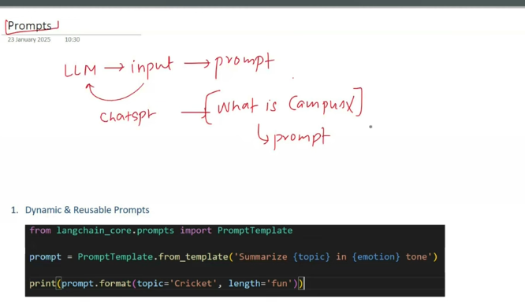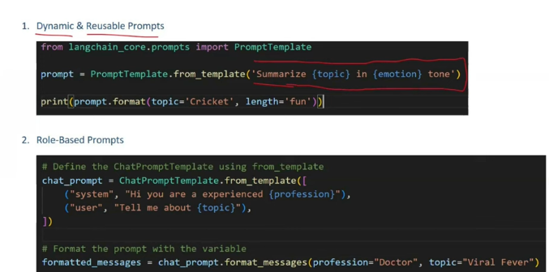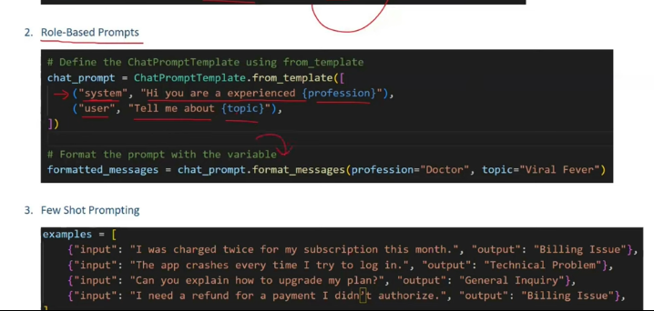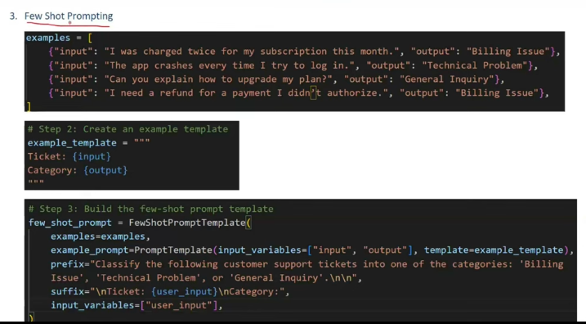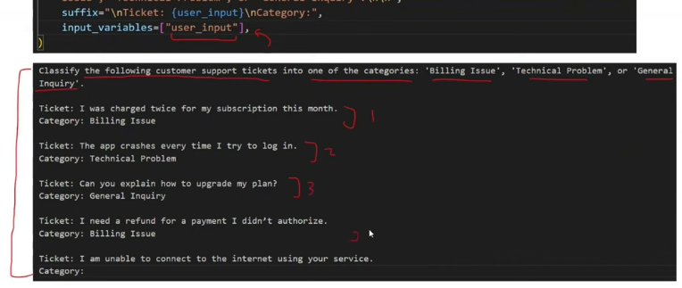

**CHAINS**

Using this we will build the pipes.

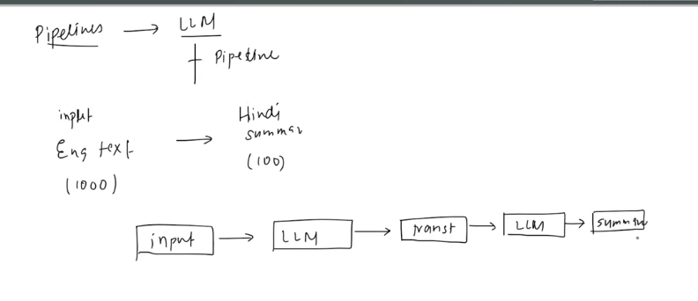

Give text as input and call the chains.

This helps in making the pipeline, output from the previous steps are passed on as input to the next stage

The chains can be more complex like

1. Sequential
2. Parallel
3. Conditional chain.
4. Combination of everything.

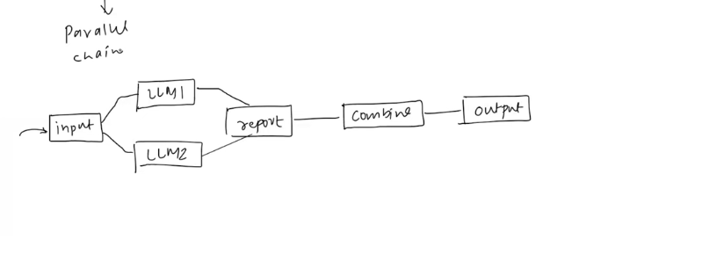

Conditional pipeline

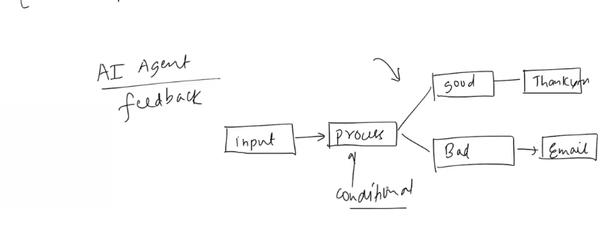

**INDEXES + components of indexes**

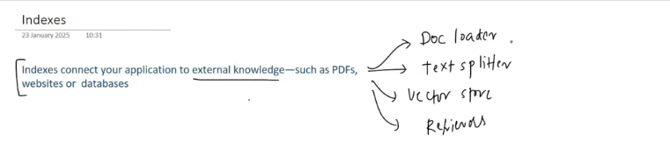

There are some concepts on which the gpts are not trained. Because those concepts are not fed as input while training.

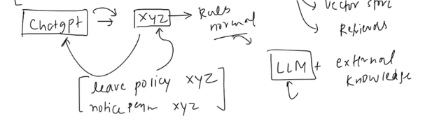

Now if you ask the input to the llms, who is prime minister of india , and the leave policy of the company, bt can be answered because the leave policy os given as input to the llms using the external knowledge.

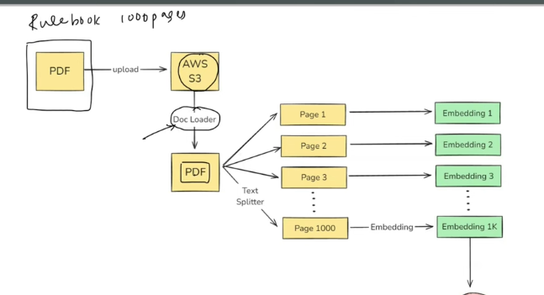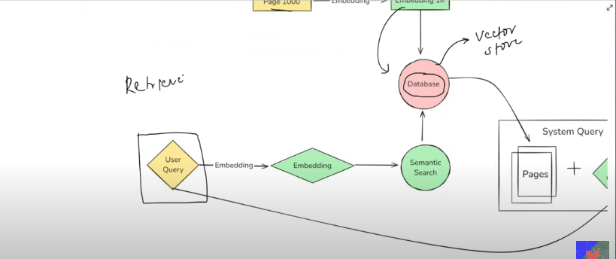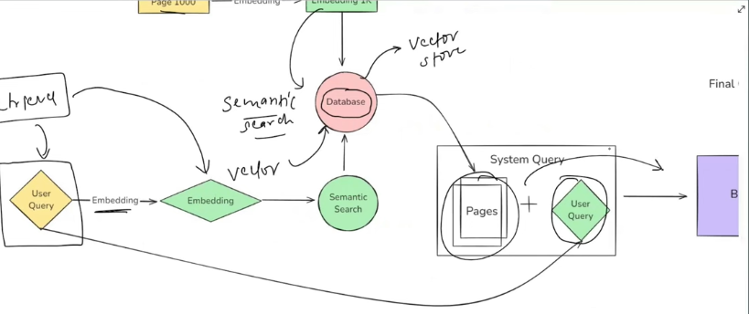

**MEMORY**

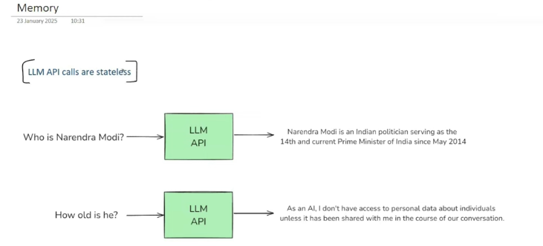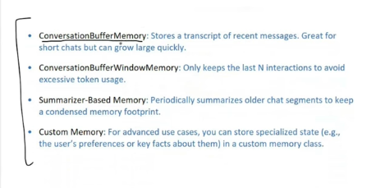

**AGENTS**

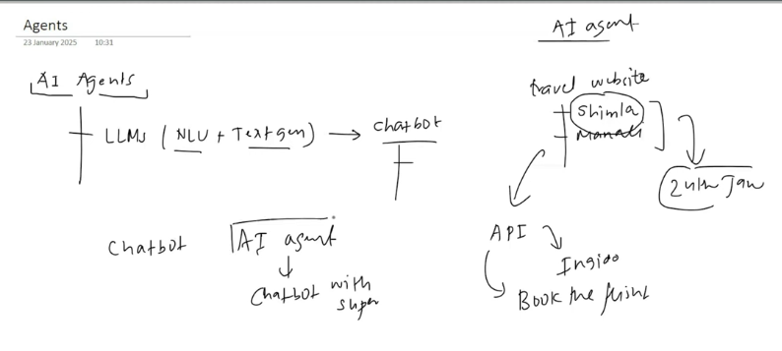

If you ask what is the bets tourist destination to visit on Jan24:

Chatbot: will telll the places  
agennts :   
1. Tells the places

2. Which is the best path

3. Cost to travel to that destinantion.

4. Do you want to book the tickets.

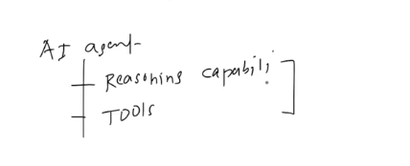

This is the difference between the ai agents and the chatbot.

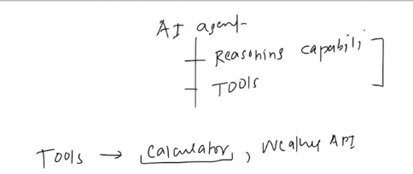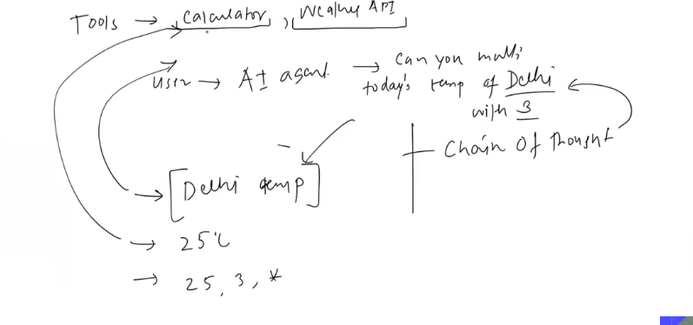

When the user asks the question the agents will go and check is there any availability of the something to meet the requirements. Like what is the weather and to give the answer after mutliplying?

These things are possible using the reasoning capability, one of the reasoning capabilities are the “**chain of thoughts**”

**Components**

**Models**